Name: | _________Solutions_______________ |  |  |  |  | Date: ___________
 | Year 10 Maths Extension/General  Investigation 1, 2016  Topic - Linear Functions  In class component |  |  |  |  | 36  = %
Total Time: | 60 minutes
Reading Time: | 5 minutes
Working Time: | 55 minutes
Weighting: | 10% of the Semester.
Equipment: | Scientific Calculator
Date out: |  | Week ____ Date _____________ |  | Date Due: | Week ____ Date _____________
Take home component weighting: |  | 0% of the Semester |  | In-class component weighting: | 10% of the Semester.
AIM: In this assessment, you will be investigating linear functions, in particular:
- drawing their graphs from their equations
- deriving their equations from their graphs and
- deriving their equations from tables of values

1. | [12 marks: 3, 3, 3, 3]
 | Graph the following lines on the axes provided:
a) | y = 2x - 3  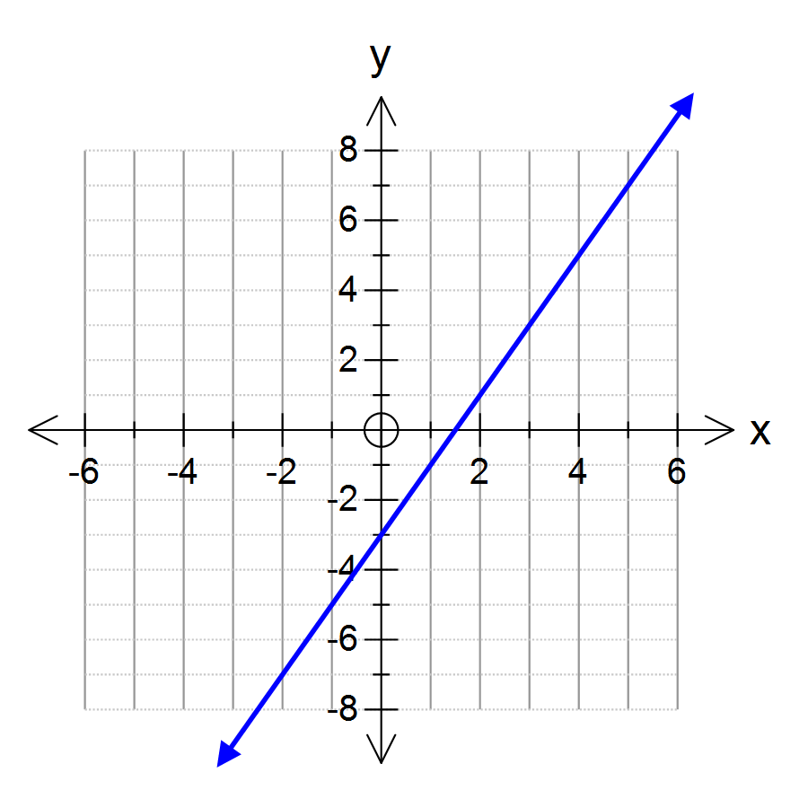 | b) | y = 5 -  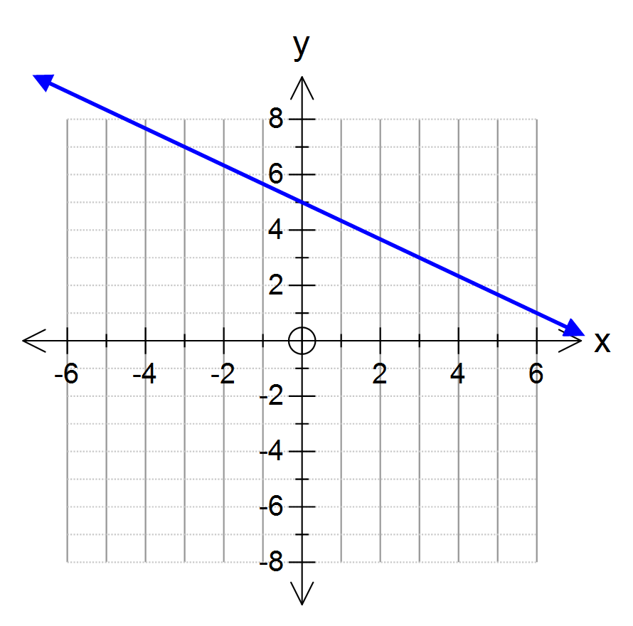
c) | 3x + y = 6  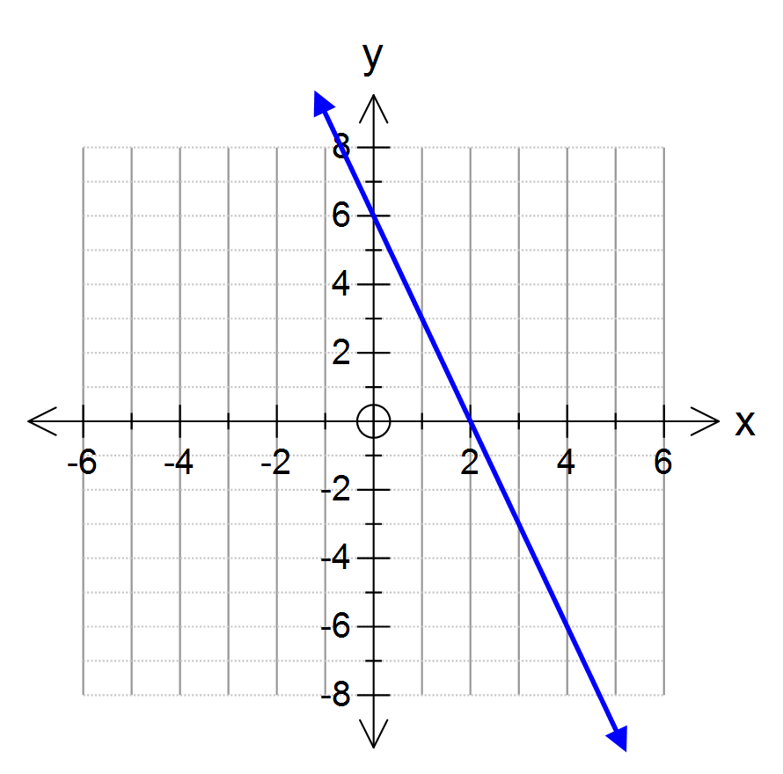 | d) | 4x – 3y = 12  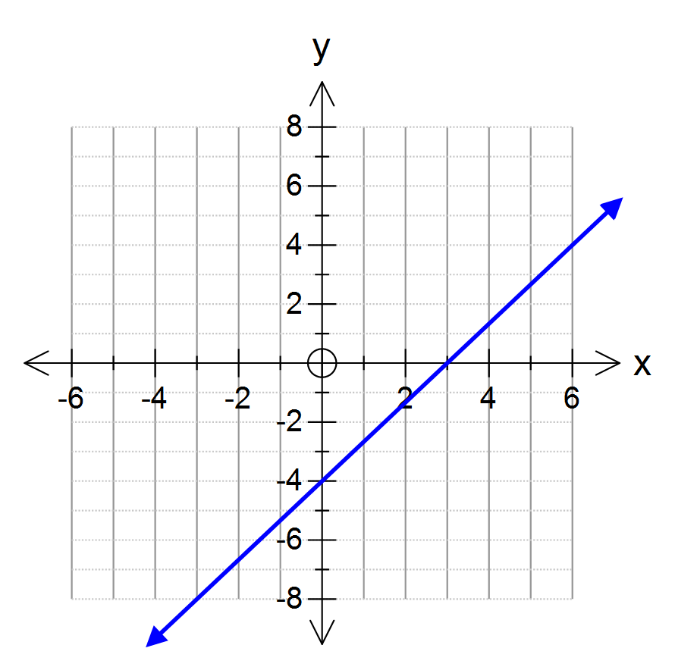

Mark allocation for each part:
Correct y intercept
Correct x intercept
Straight line between
2. | [6 marks: 2, 2, 2]
 | Give the equations of the three lines in the graph on the right
a) | Line A  y = 2x-3 | 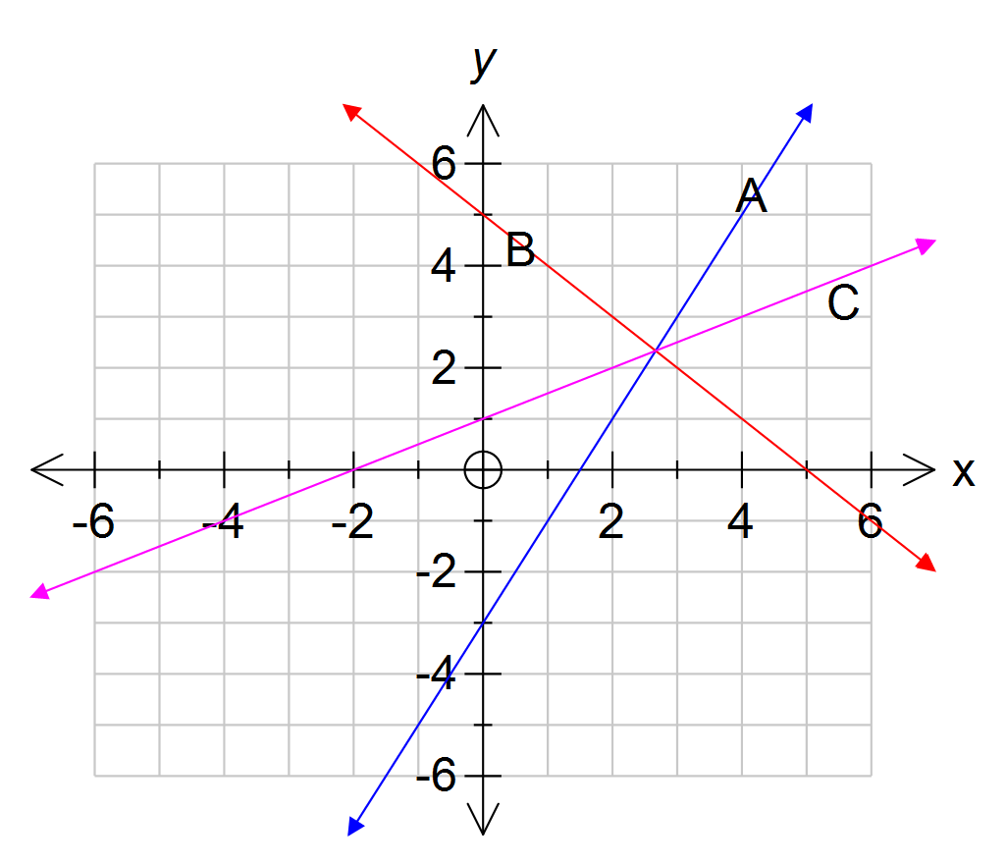
b) | Line B  y = 5 - x
c) | Line C  y = x/2 + 1

3. | [6 marks: 2, 2, 2]
 | Give the equations of the three lines in the graph on the right
a) | Line A  y = 4 | 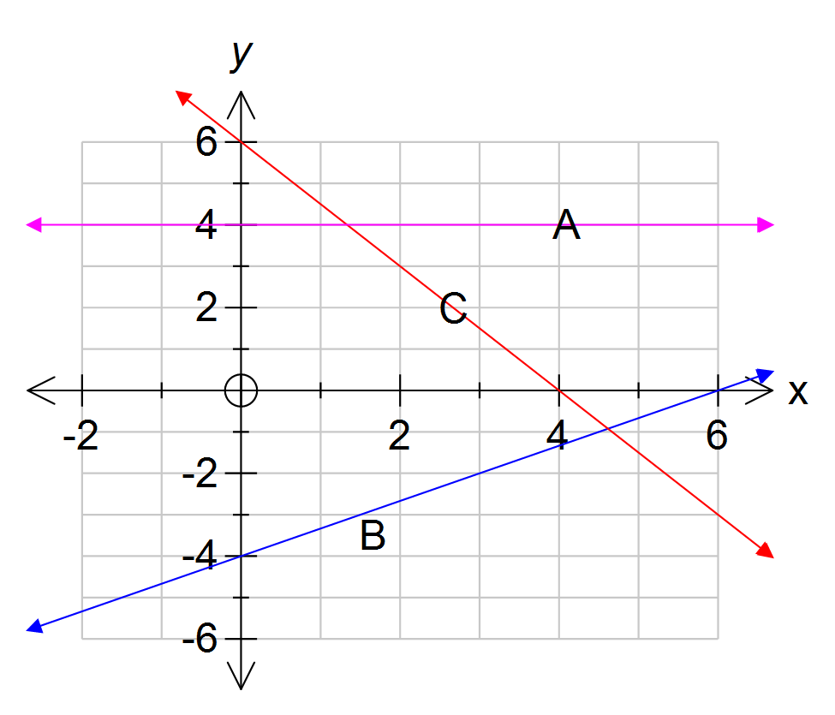
b) | Line B  y = 2x/3 - 4
c) | Line C  y = 6 - 3x/2 or -3x/2 + 6

Mark allocation a:
Correct equation
(with no extra bits)

Mark allocation for b) & c):
Correct y intercept
Correct gradient

4. | [12 marks: 2, 2, 2, 2, 2, 2]
 | For each of the linear functions defined by the tables below, state the equation:-
a) | x 0 1 2 3 4 5 6  y 6 10 14 18 22 26 30  First difference 4 4 4 4 4 4  Equation is y = 4x + 6 Correct y gradient Correct x intercept
b) | x 0 1 2 3 4 5 6  y 15 12 9 6 3 0 -3  First difference -3 -3 -3 -3 -3 -3  Equation is y = -3x + 15 Correct y gradient Correct x intercept
c) | x 0 1 2 3 4 5 6  y 16 25 34 43 52 61  First difference 9 9 9 9 9  Equation is y = 9x + 7 Correct y gradient Correct x intercept
d) | x 0 2 4 6 8 10 12  y -3 4 11 18 25 32  First difference 7 7 7 7 7  Equation is y = 7x/2 – 10 Correct y gradient Correct x intercept
e) | x 3 6 9 12 15 18  y 29 23 17 11 5 -1  First difference -6 -6 -6 -6 -6  Equation is y = -3x + 35 Correct y gradient Correct x intercept
f) | x 20 30 40 50 60 70 80  y 117 97 77 57 37 17 -3  First difference -20 -20 -20 -20 -20 -20  Equation is y = -2x + 157 Correct y gradient Correct x intercept

